Introduction to Databases Exercise Solution

Ankit

Group 5

Ques. 1 Create Database

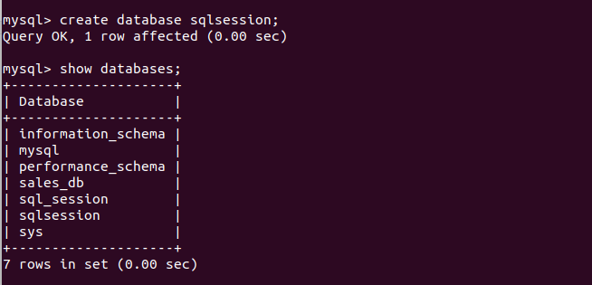

Ques. 2 Design Schema

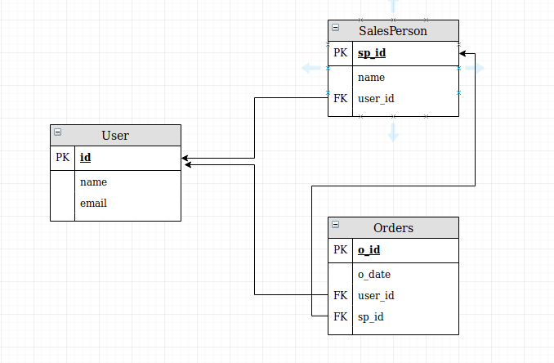

Ques. 3 Create tables

1. User Table

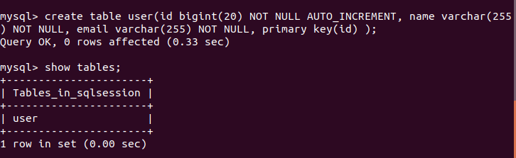

b. SalesPerson Table

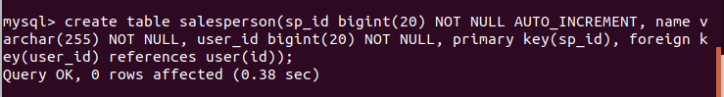

c. Orders Table

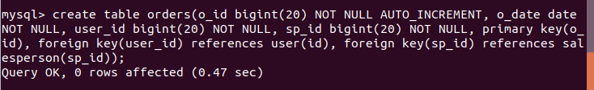

Ques. 4 Insert sample data

a. Into User Table

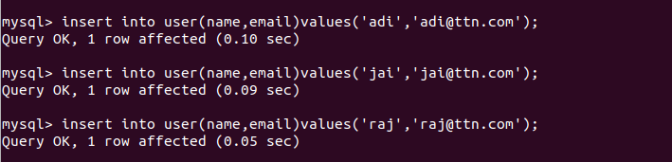

b. Into Salesperson Table



c. Into Orders Table



Ques. 5 Find the sales person have multiple orders.

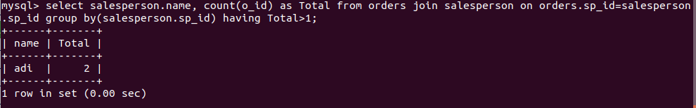

Ques. 6 Find the all sales person details along with order details.

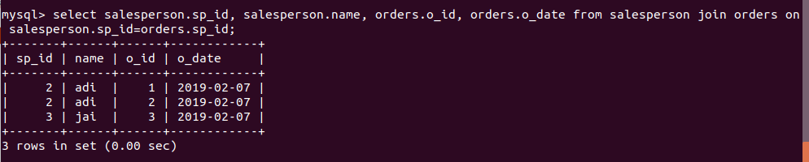

Ques. 7 Create index



Ques. 8 How to show index on a table

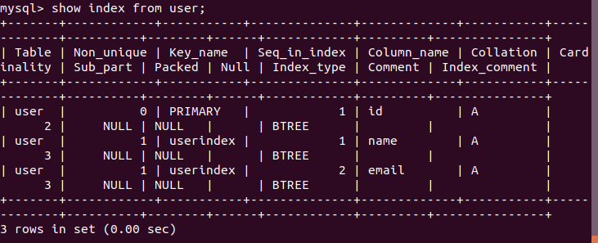

Ques. 9 Find the order number, sales person , along with the customer to whom that order belongs to.

